**Respircare Patient Management System Instructions**

# 1. Install and Uninstall

## 1.1. Install

**1.1.1.** Double click“setup.exe”run the installation program, according to the setup prompt to install.

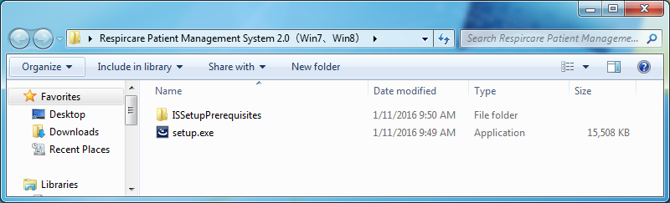

*Note: If the operating system has no install* *Microsoft SQL Server 2014 Express RTM Local DB and Microsoft .NET Framework 4.5 component, then click“install” according to the setup prompt to install relevant component,* *if the operating system has installed above components, the following interface will be not showed.*

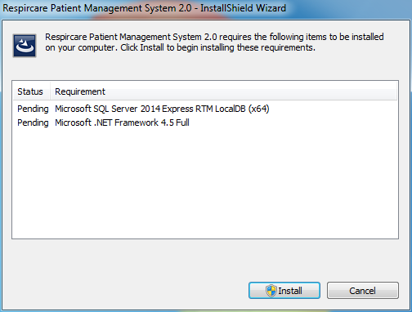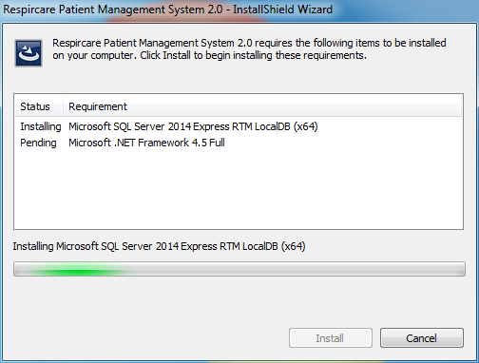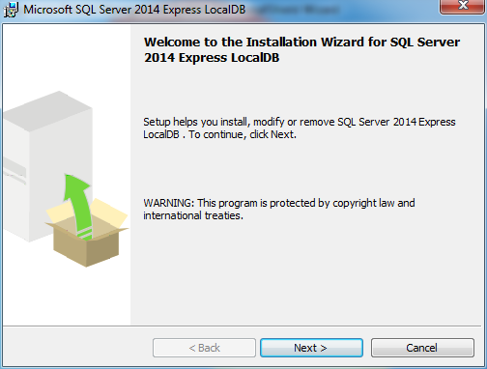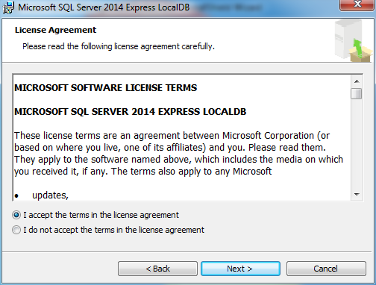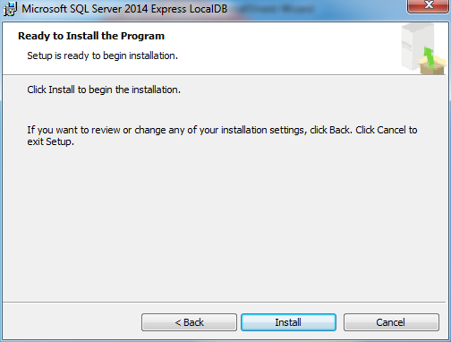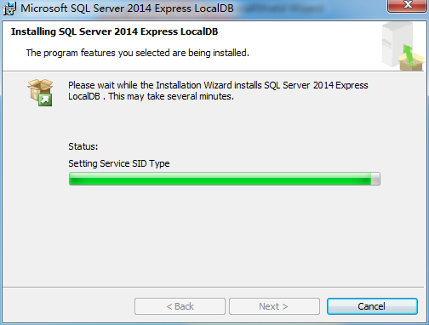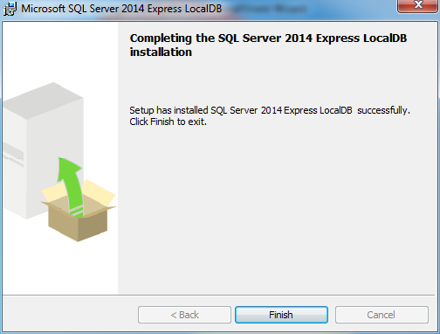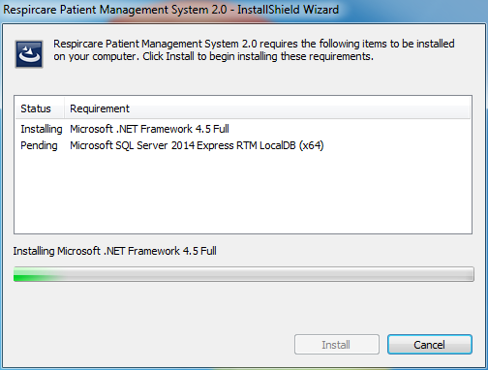

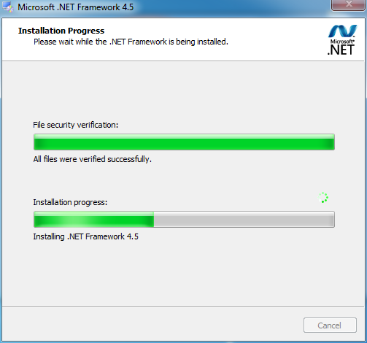

**1.1.2.** According to the following setup prompt to install.

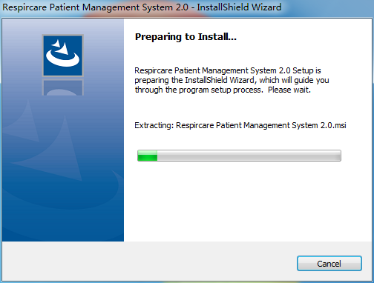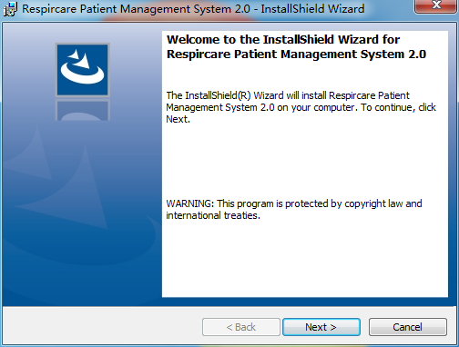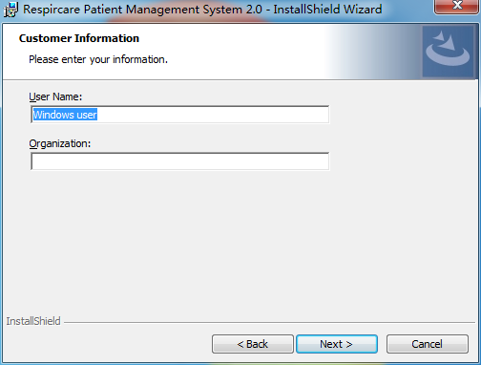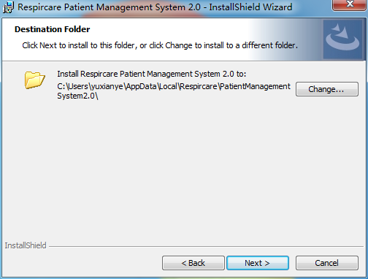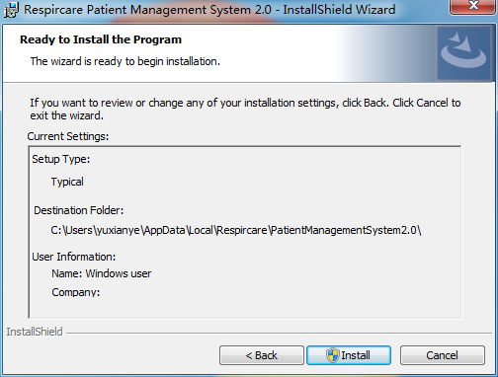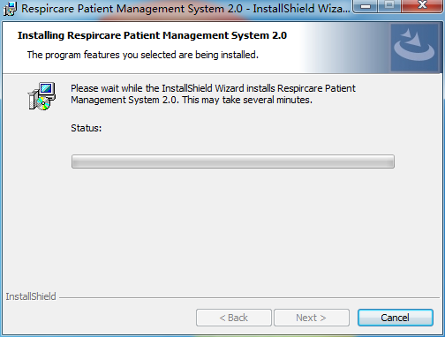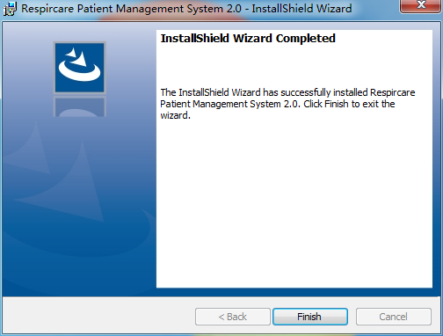

**1.1.3.** Double click on the desktop or click the start menu of “Respircare Patient Management System 2.0”run the “Respircare Patient Management System 2.0”after installation.

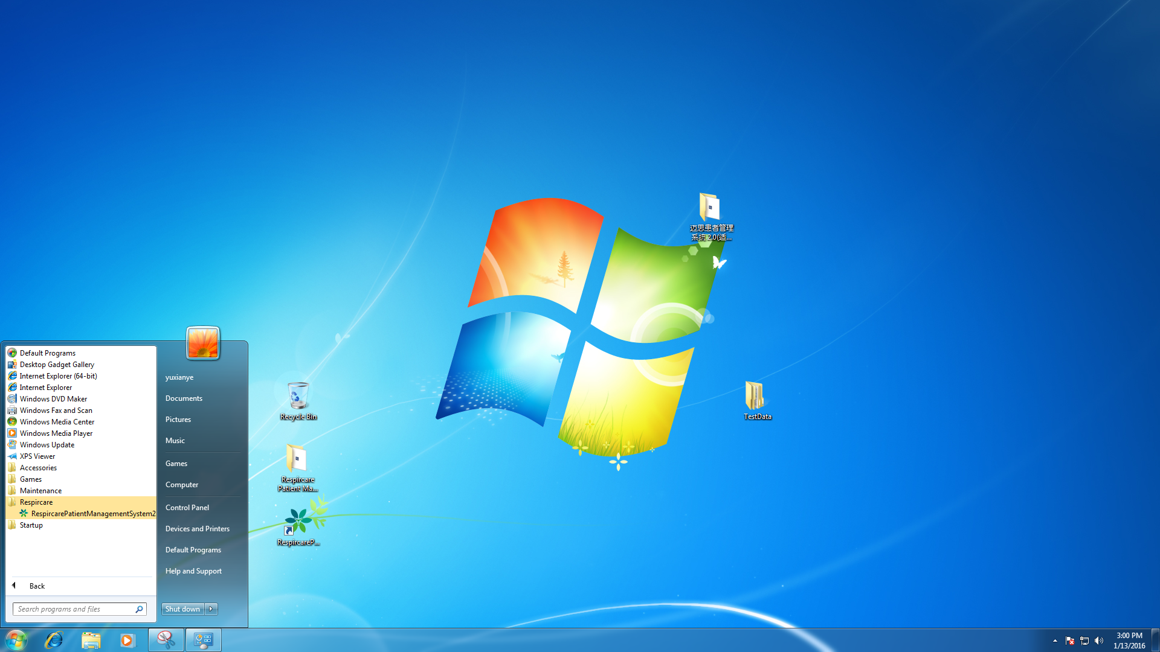

## 1.2. Uninstall

**1.2.1.** Click“Start”>“Control Panel”>“Uninstall Program”，enter into“Programs and Features”interface.

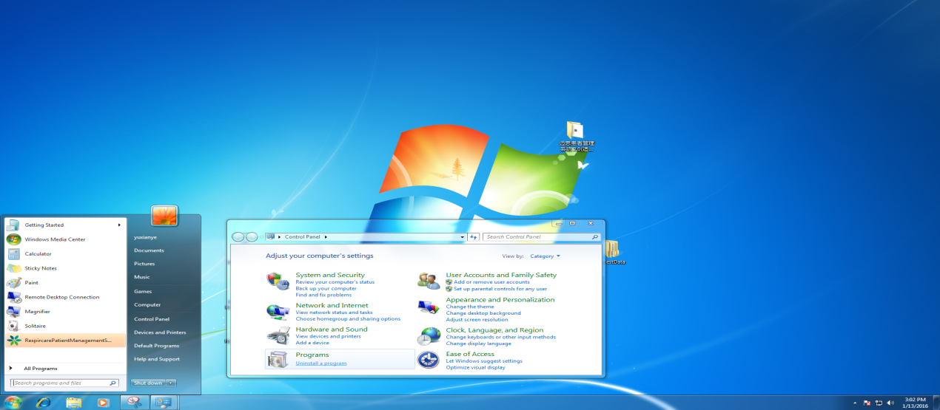

**1.2.2.** Select“Respircare Patient Management System 2.0”，then click “uninstall”，According to the prompt to complete uninstall.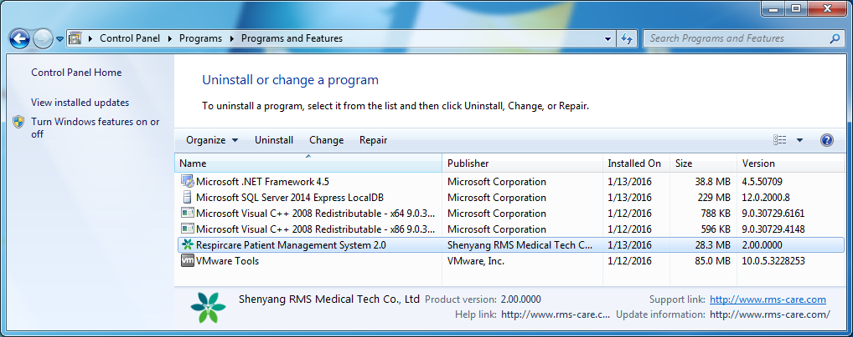

# 2. Startup and Shutdown

## 2.1. Startup

**2.1.1.** Double click desktop or click start menu of “Respircare Patient Management System 2.0”icon to startup system.



**2.1.2.** Enter into system main interface after welcome interface loading.



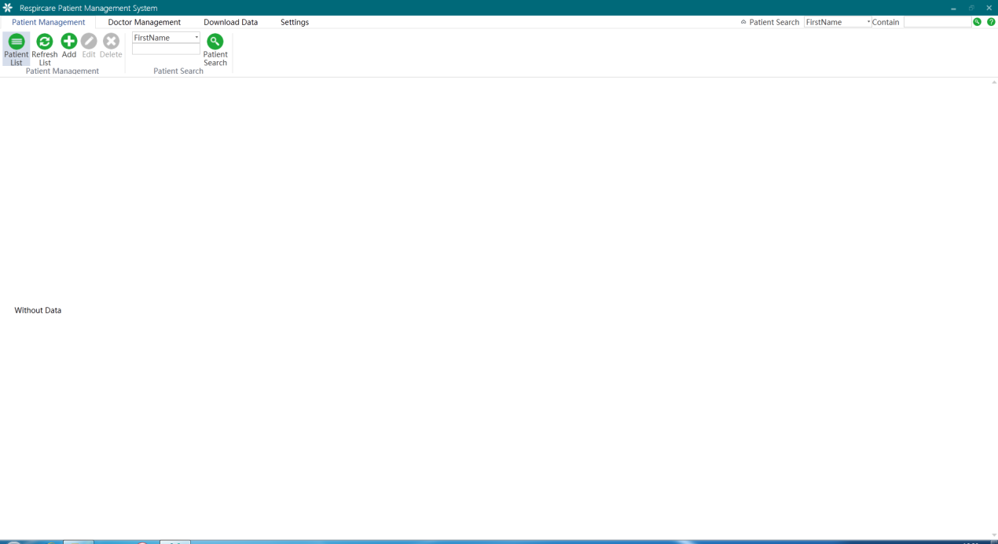

## 2.2. Shout down

**2.2.1.** Click on the window in the top right corner of the "X" to close the software, or right click“”icon in the Taskbar, click the "close window" to close the system in the pop-up menu..

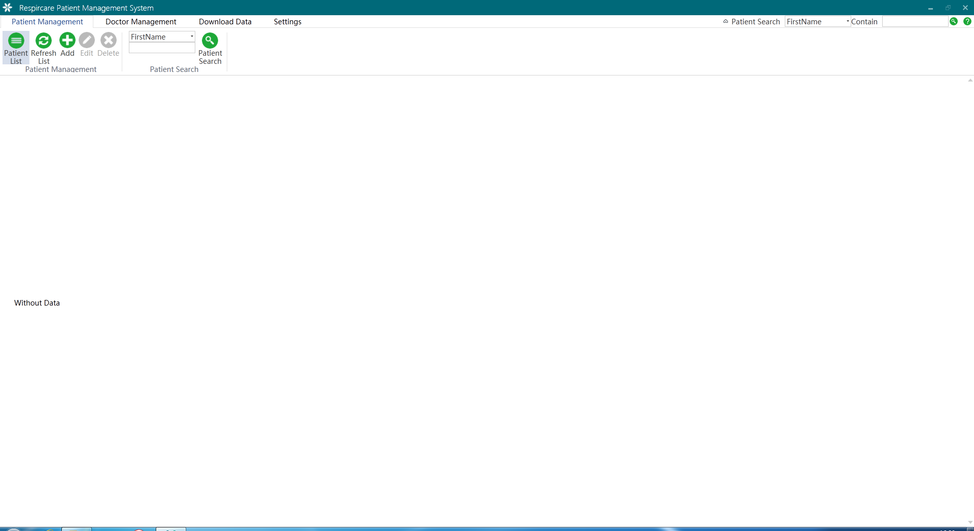 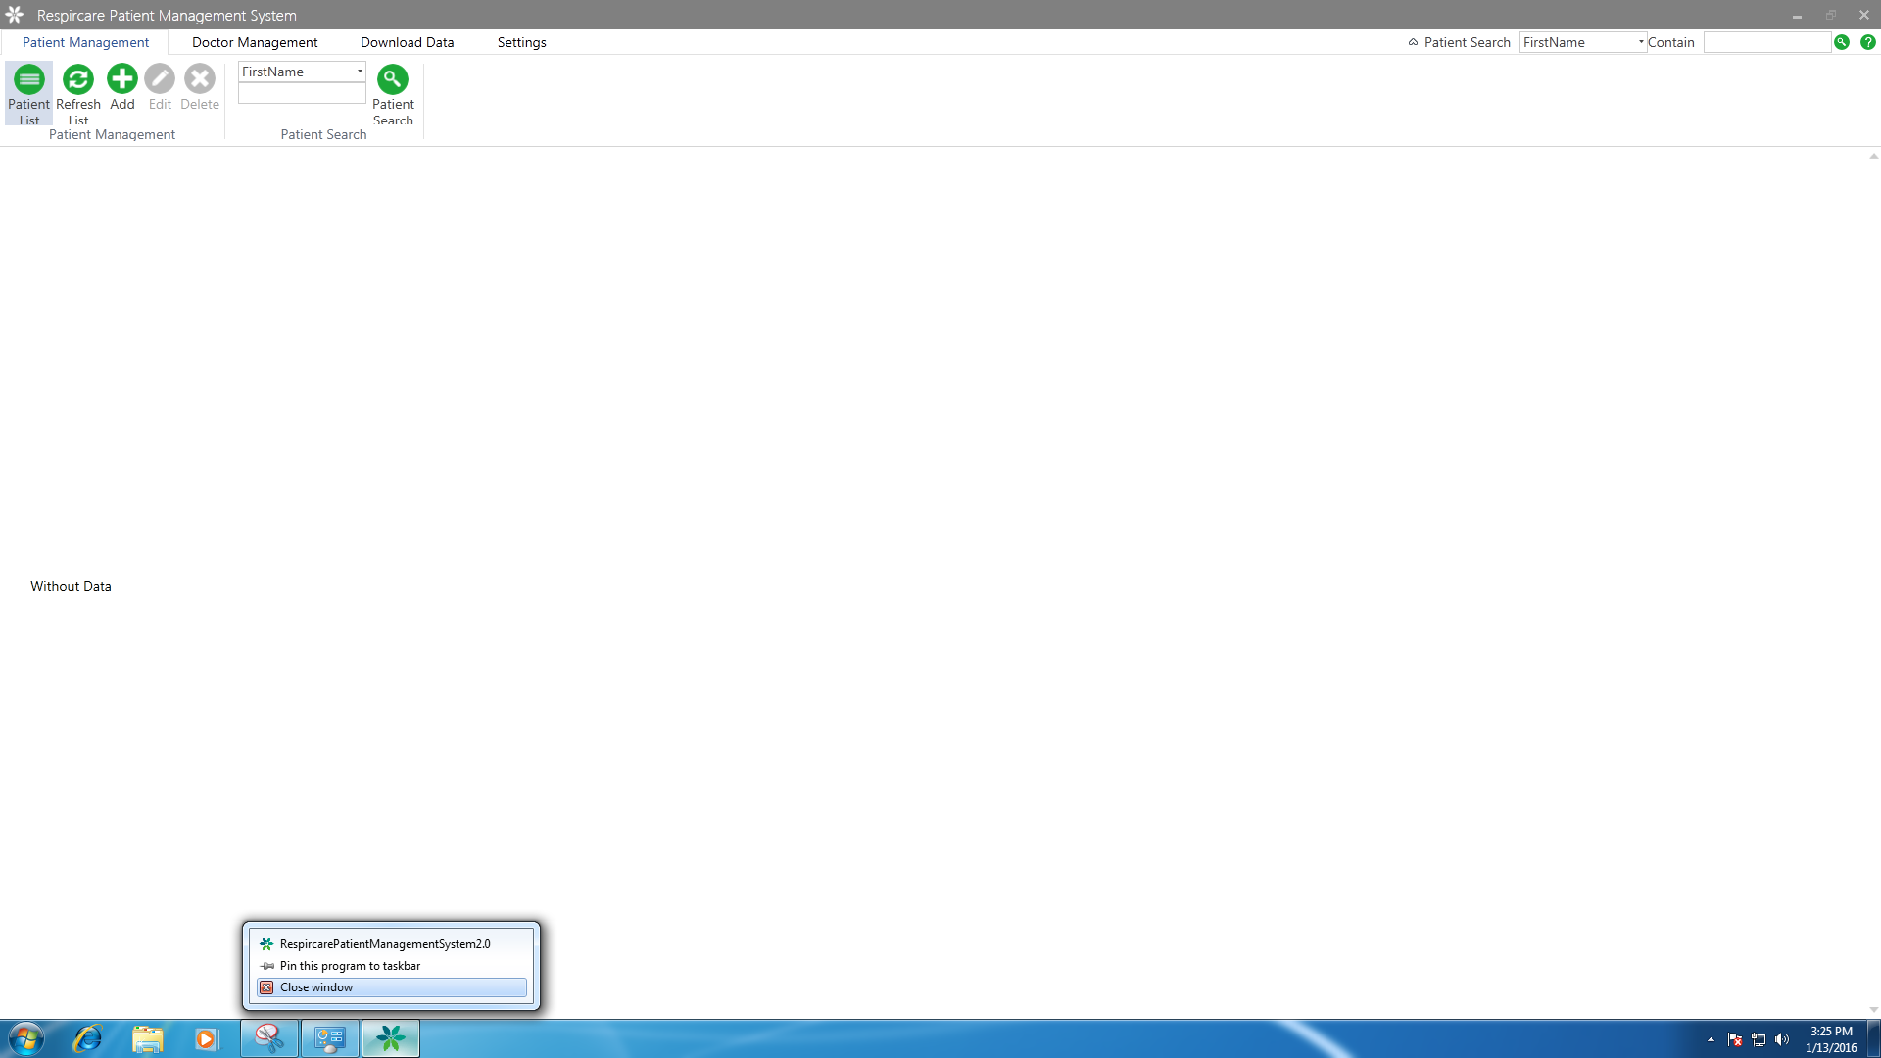

# 3. Patient Management

## 3.1. Add Patient

**3.1.1.**Click “add” in the menu of “Patient Management” pop up "add patient" interface.

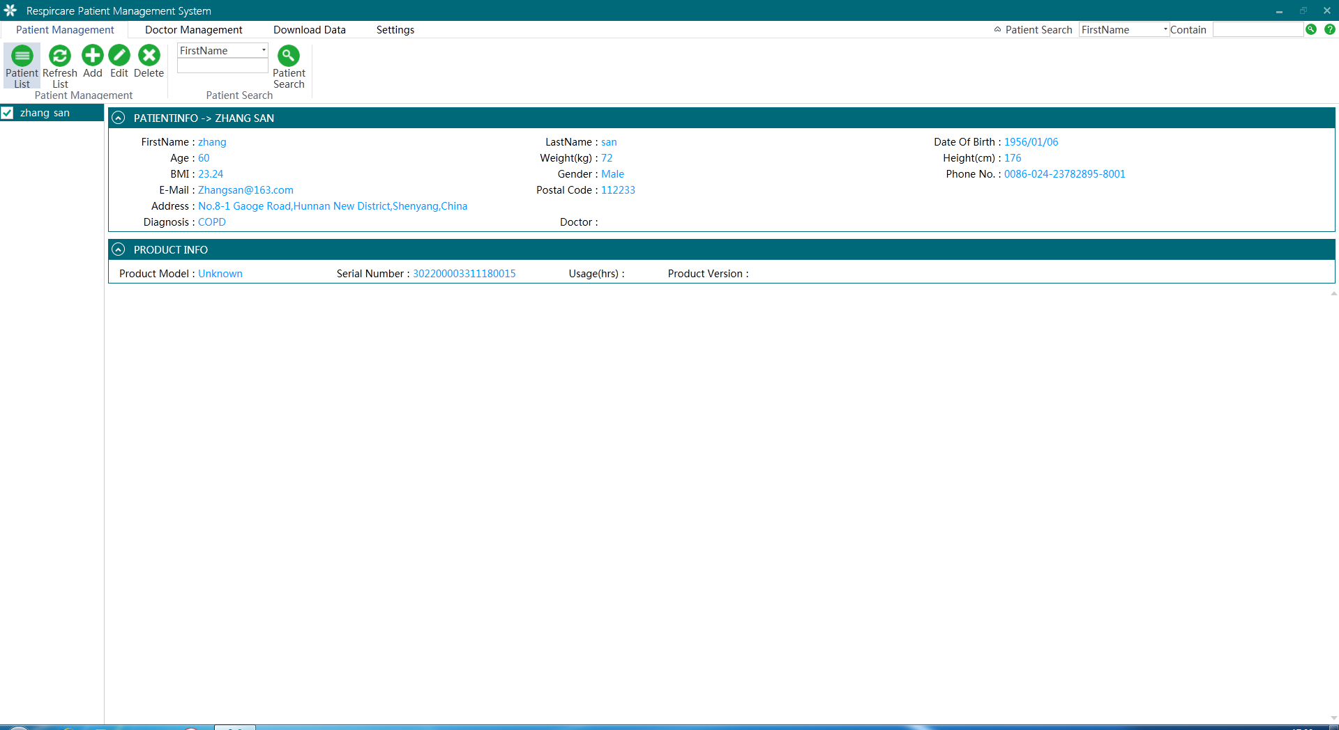

**3.1.2.** Fill in the patient information in“add patient” interface, then click “confirm”button. The name and serial number must fill out, serial number is 18 SN code on the label, other contents according to the actual situation to fill in or blank. Add doctor information in the "doctor management" module when select doctor, see the details in“Doctor Management”>“Add Doctor”chapter.

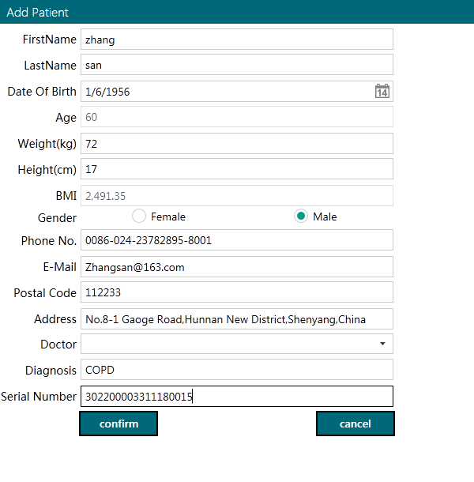

**3.1.3.** The patient information could be viewed in the patient list.

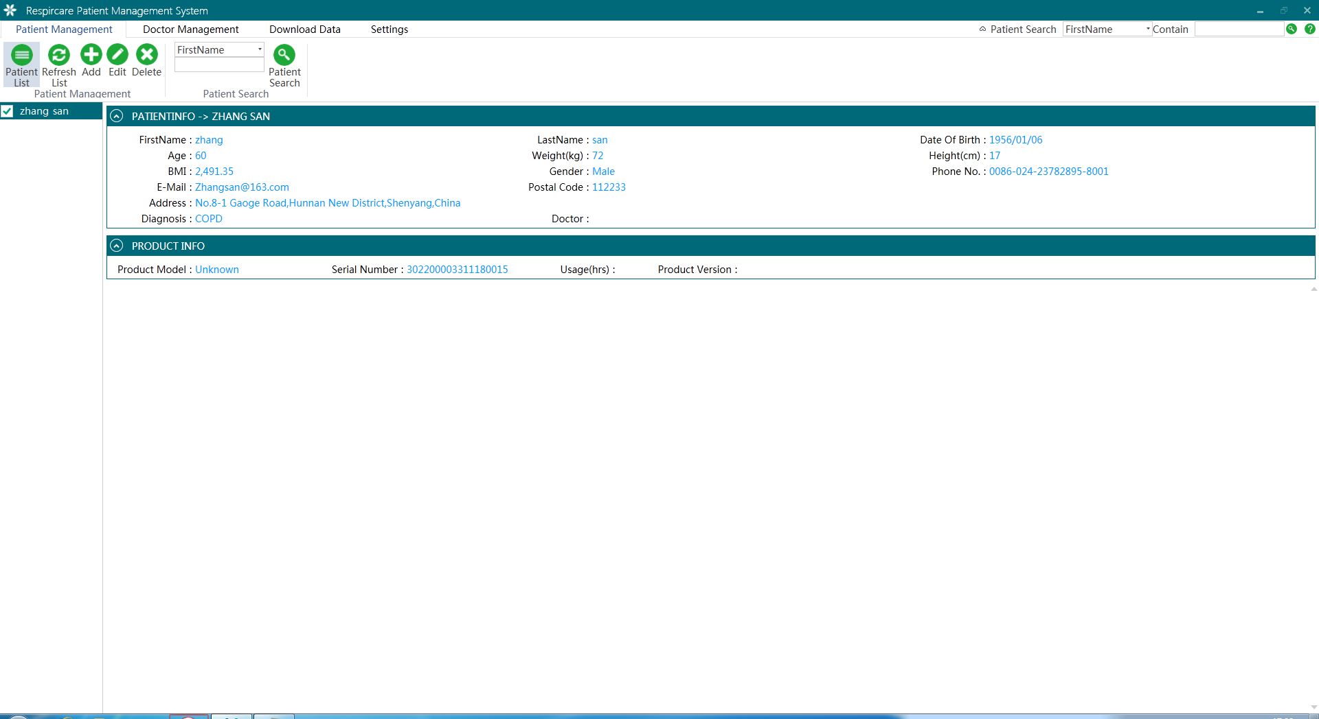

## 3.2. Edit Patient

**3.2.1.**Select edit patient in “patient list”, click“edit”pop up“edit patient”interface.



**3.2.2.** Modify patient information in“Edit Patient”interface, then click“Confirm”to finish edit, the name must fill out, serial number cannot be modified, other contents according to the actual situation to fill in or blank. Add doctor information in the "doctor management" module when select doctor, see the details in“Doctor Management”>“Add Doctor”chapter.

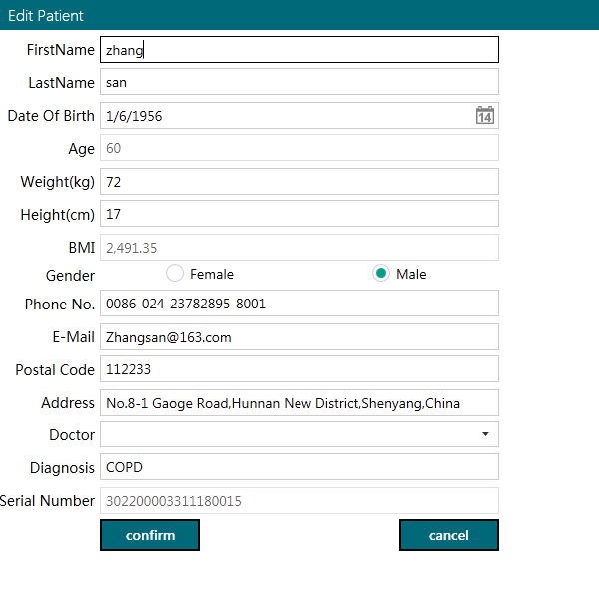

## 3.3. Delete patient

**3.3.1.** Select the patient to delete in the patient list, click “Delete” pop-up "delete" interface.



**3.3.2.** Press Confirm the Patient Delete Menu to delete the information which including the service information. The deleted information could not be recovered, please be cautious to operate.

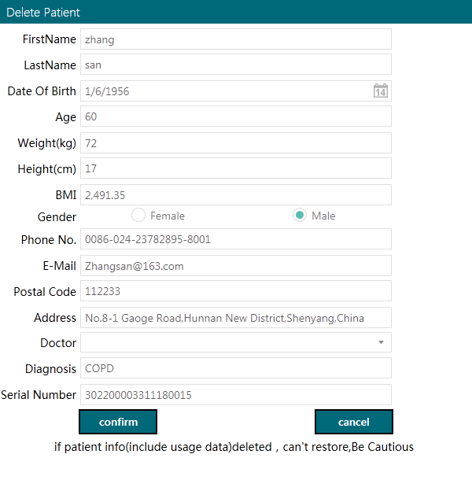

## 3.4. Overview of Patient Information

Press the left patient name on the menu, all the related information will be shown on the right, including the patient information, product information and statistical information. If there is no service information of patient, the statistical information will not be shown. If you require to check this information, it is necessary to download the product data, details refer to Data Download. If detailed service information is required, double press the patient menu, if there is no service data, the main menu could not be entered.

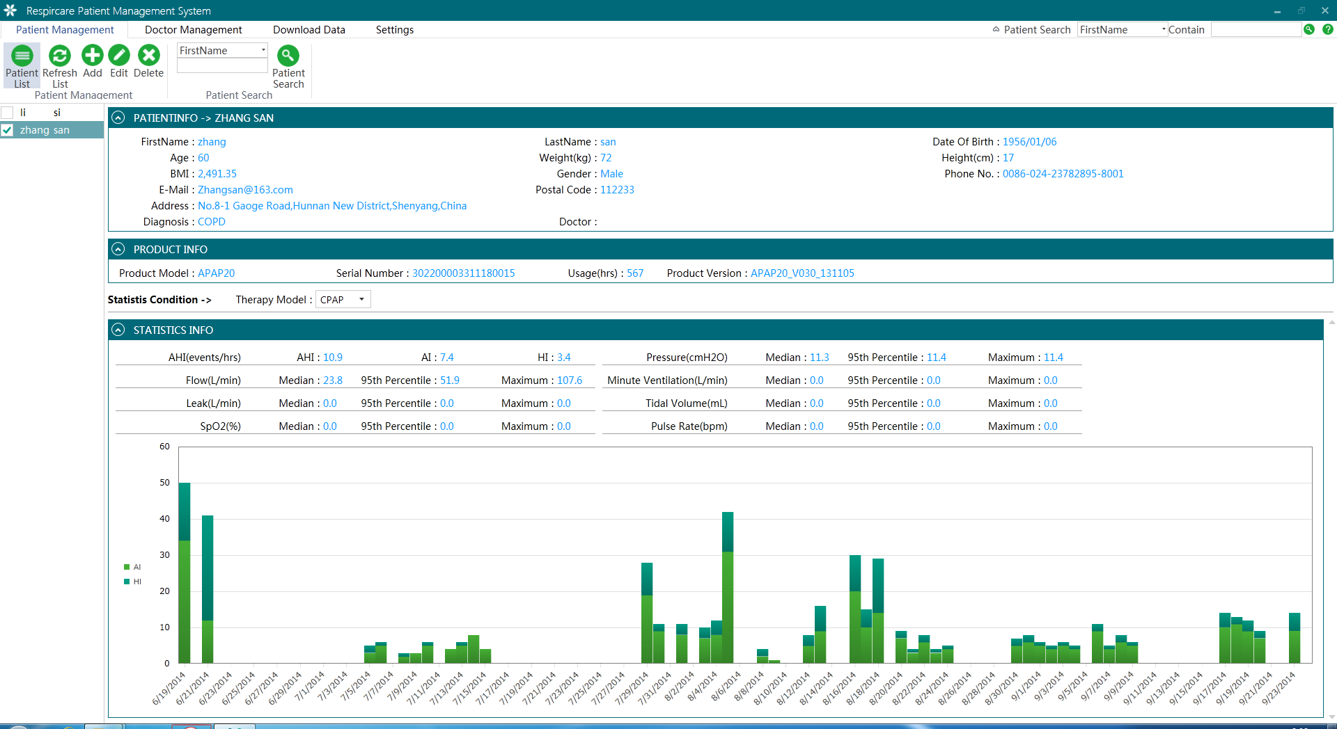

**3.4.1.** Patient Data is the input information when adding new patient, here only reading is available and not editing. If editing is required, refer to Patient Management> Edit Patient Chapter.



**3.4.2.** Product Information is the related data that patient uses product, including product model, serial number, total service time and products version. The serial number is the filled product serial number when adding new patients. Product model, total service time and product version could be read from SD card, the Product Information only could be checked and not revised.



**3.4.3.** Statistical Condition could statistic all the data under the treatment mode as per the chosen mode, the result will be displayed on the Statistical Information. The treatment Mode means the chosen mode when using the device, the statistical information differs as per the different treatment mode.



**3.4.4.** Statistical Information means the data from memory card when using the device to be analyzed finally.

AHI, Flow, Pressure are all the average value of total working days on the treatment mode, the statistical items will differ as per different treatment modes.



The images of AI and HI are the statistical pictures of times of AI and HI each day on the treatment mode.



## 3.5. Patient Searching

Press the Searching button on the Doctor Management, to look for the patient information quickly as per searching condition and content.

**3.5.1.** Select the searching condition from the down list, fill the included content at the searching blank, then press the Search button to search the patient information.

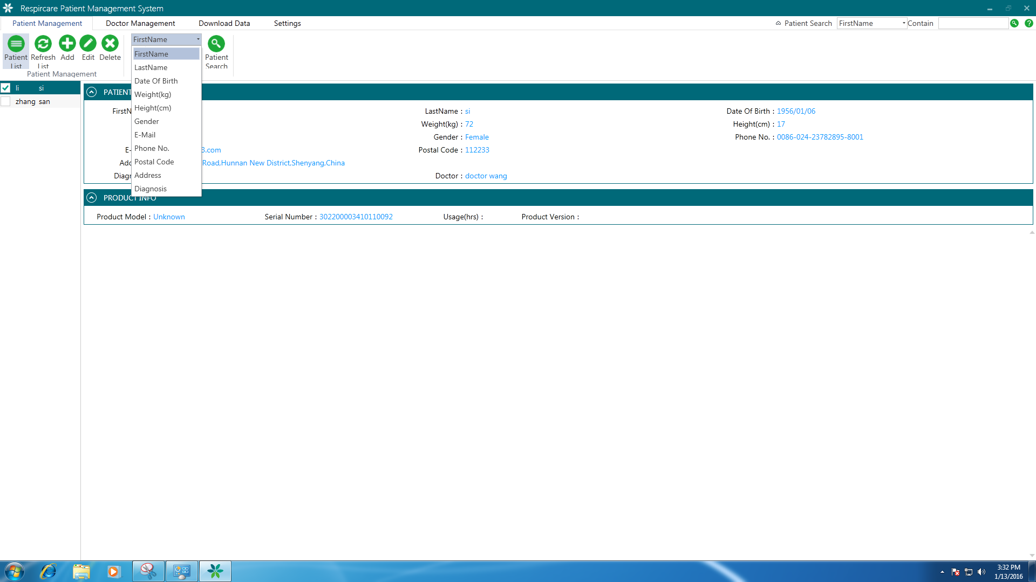 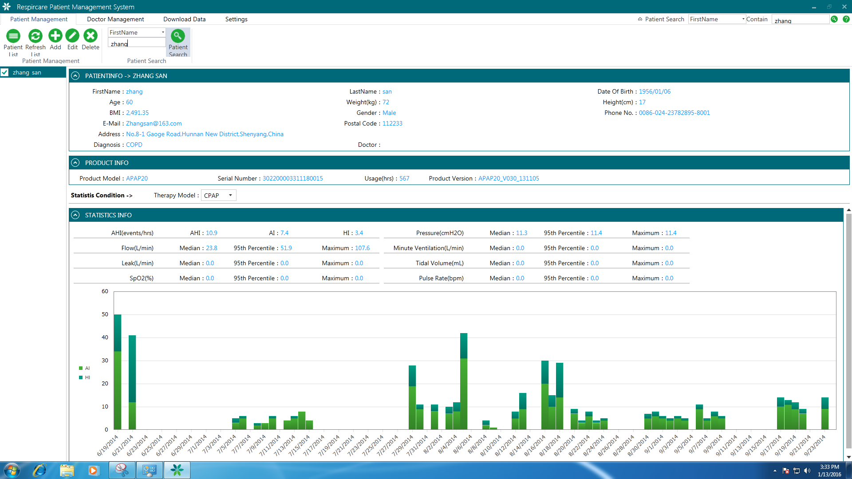

## 3.6. The Homepage of Patient

Double press the patient name from the patient list to enter the patient homepage. If there is no service data then the patient homepage could not be entered, it is necessary to download the data to use this function, for more detail refer to Data Download chapter.



The Patient Homepage is the general name of some sub interface. It includes several interfaces: statistics, abstract, detail, product setting, statistical report. Each interface shows different key points. The following will be displayed in detail.

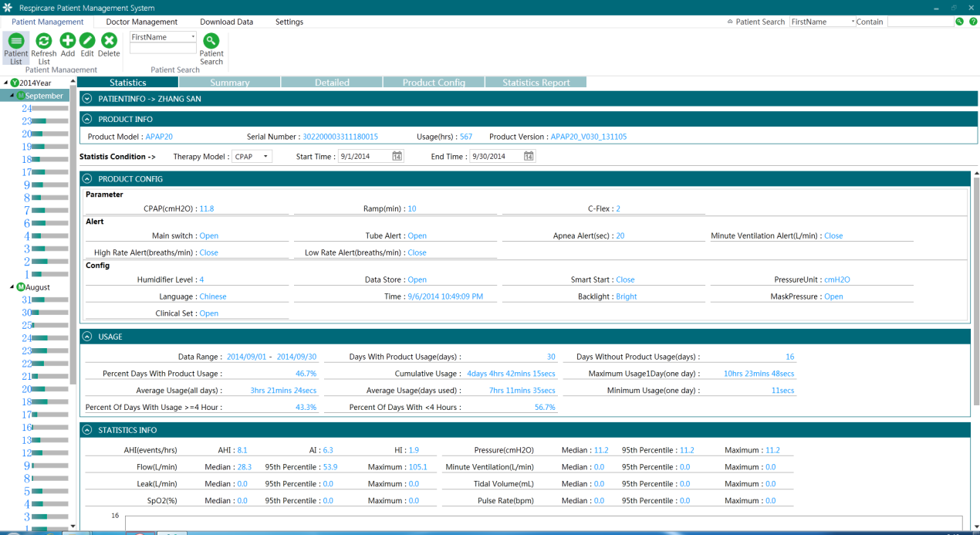

### 3.6.1. Statistics

Statistics interface is the statistical analysis for one day or several days, this interface includes patient information, product information, statistical condition, product configuration, and information statistics.

#### 3.6.1.1. Patient Information

Patient information is the input data when adding patient, here only allows to be checked but not edited. If edition is required, please refer to Patient Management> Edit Patient chapter, patient information is in folding state in default.



#### 3.6.1.2. Product Information

Product Information is the related information when patient uses the device, it contains the product model, SN, total service time and product version. SN is the filled serial number when adding patient, other information such as product model, SN, total service time and product version were read from memory card, product information could only be read not revised.



#### 3.6.1.3. Statistics Condition

Statistics Condition could analyze the data as per different treatment modes, starting time or time period, the left tree diagram and the bottom will differ as per the chosen modes

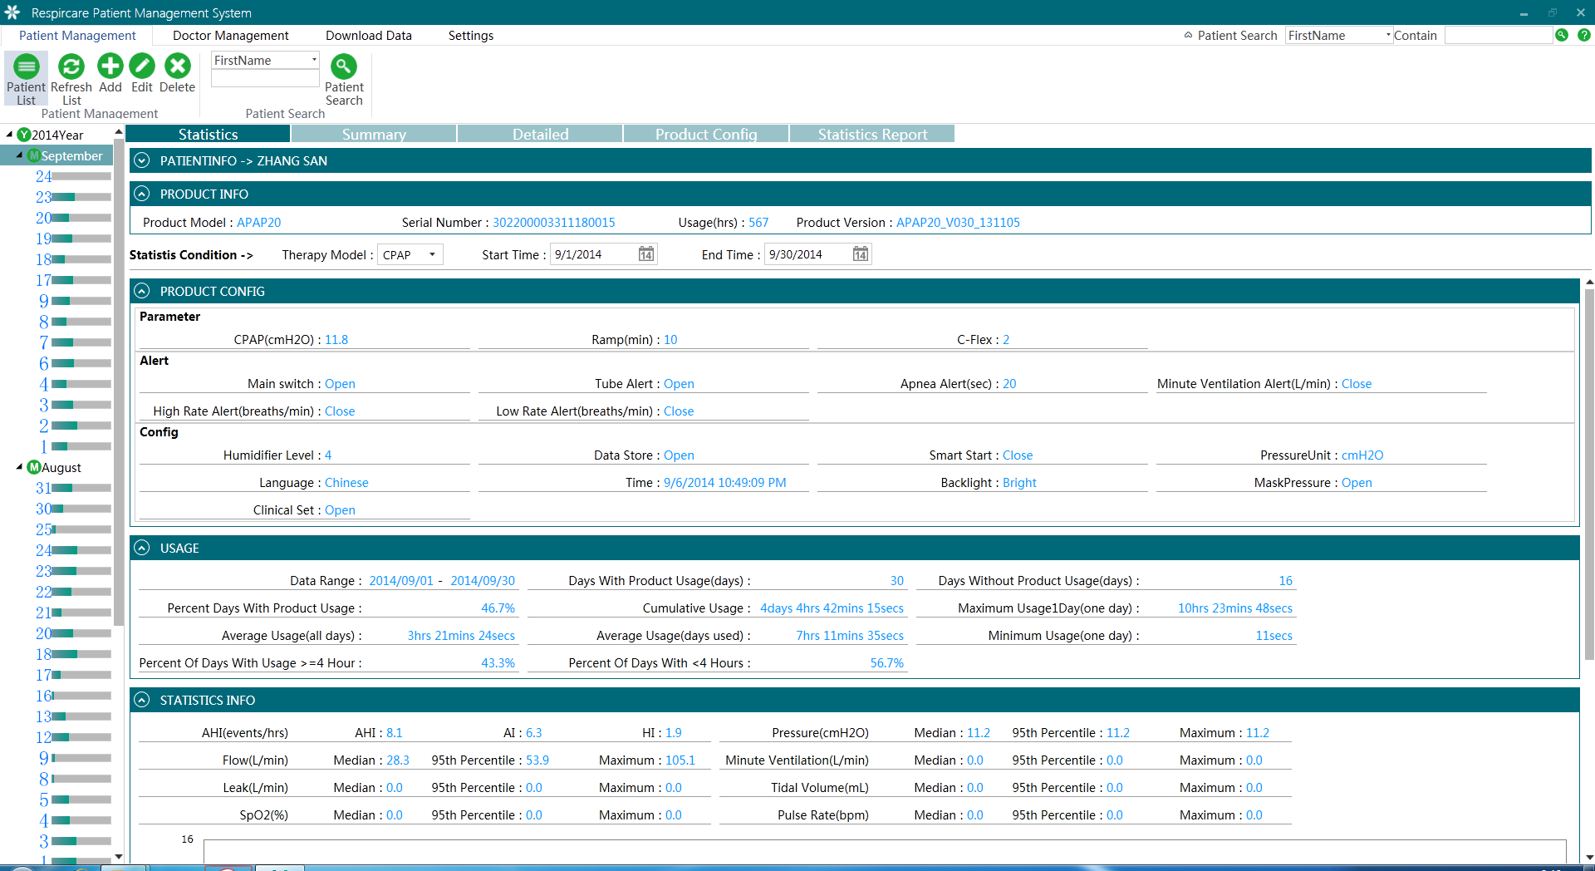

#### 3.6.1.4. Product Configuration

Product Configuration is the information during the longest usage period on chosen treatment mode. The configuration parameters will differ as per different modes.



#### 3.6.1.5. Usage Information

Usage information means the statistics of usage data on chosen treatment during time period, including compliance statistics.



#### 3.6.1.6. Statistical Information

Statistical Information is the analysis to the usage data on chosen treatment during time period.

AHI, Flow, Pressure are all the average usage value in the time period on the chosen treatment mode, the statistic items will differ as per the treatment mode.

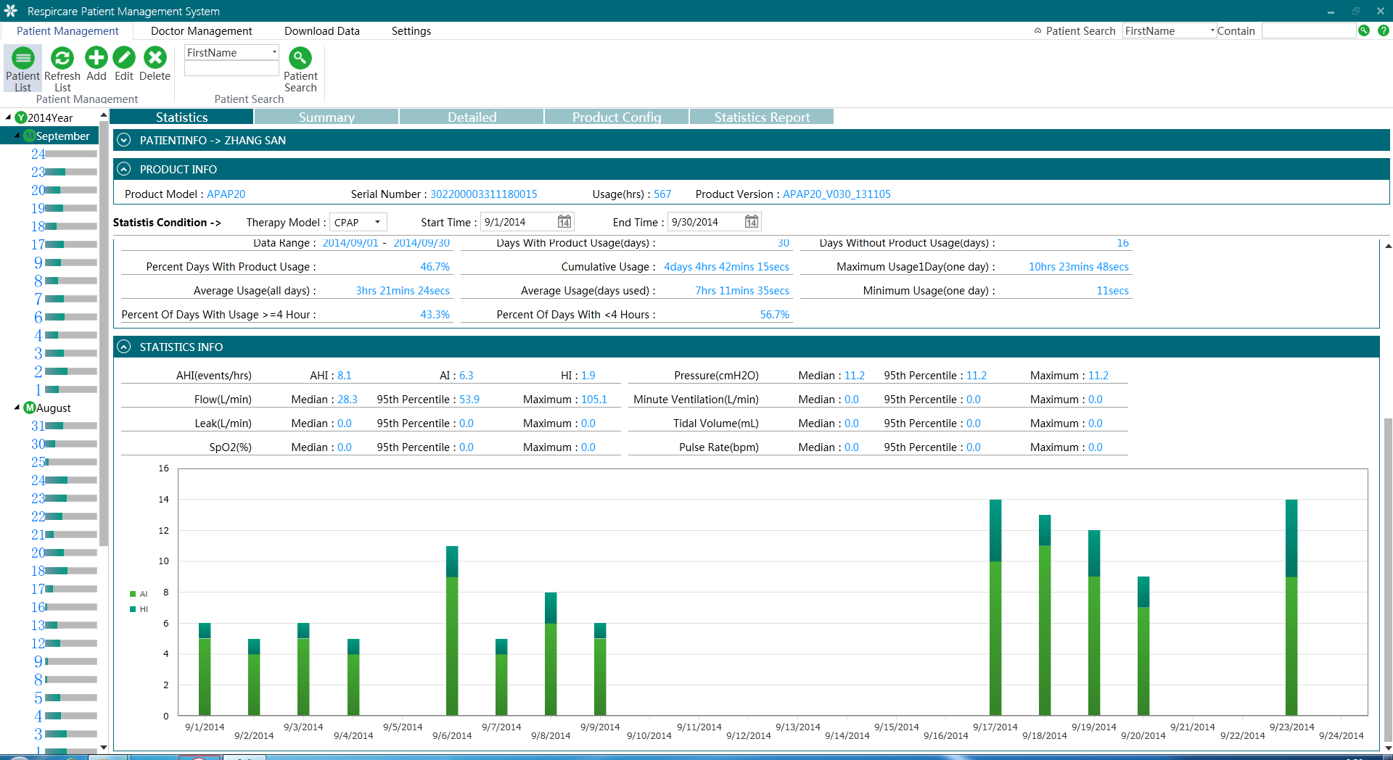

AI and HI images means the AI and HI statistic images for each day on chosen treatment mode and period.



### 3.6.2. Abstract

Abstract interface is based on the statistical data, to be shown in one image. The horizontal is the statistics of one path for one day while vertical data of each path in a day. The path quantity will differ as per different device models and treatment modes.

Press Abstract button to enter the interface. It includes Patient information, Product Information, Statistics Condition and column diagram, etc.

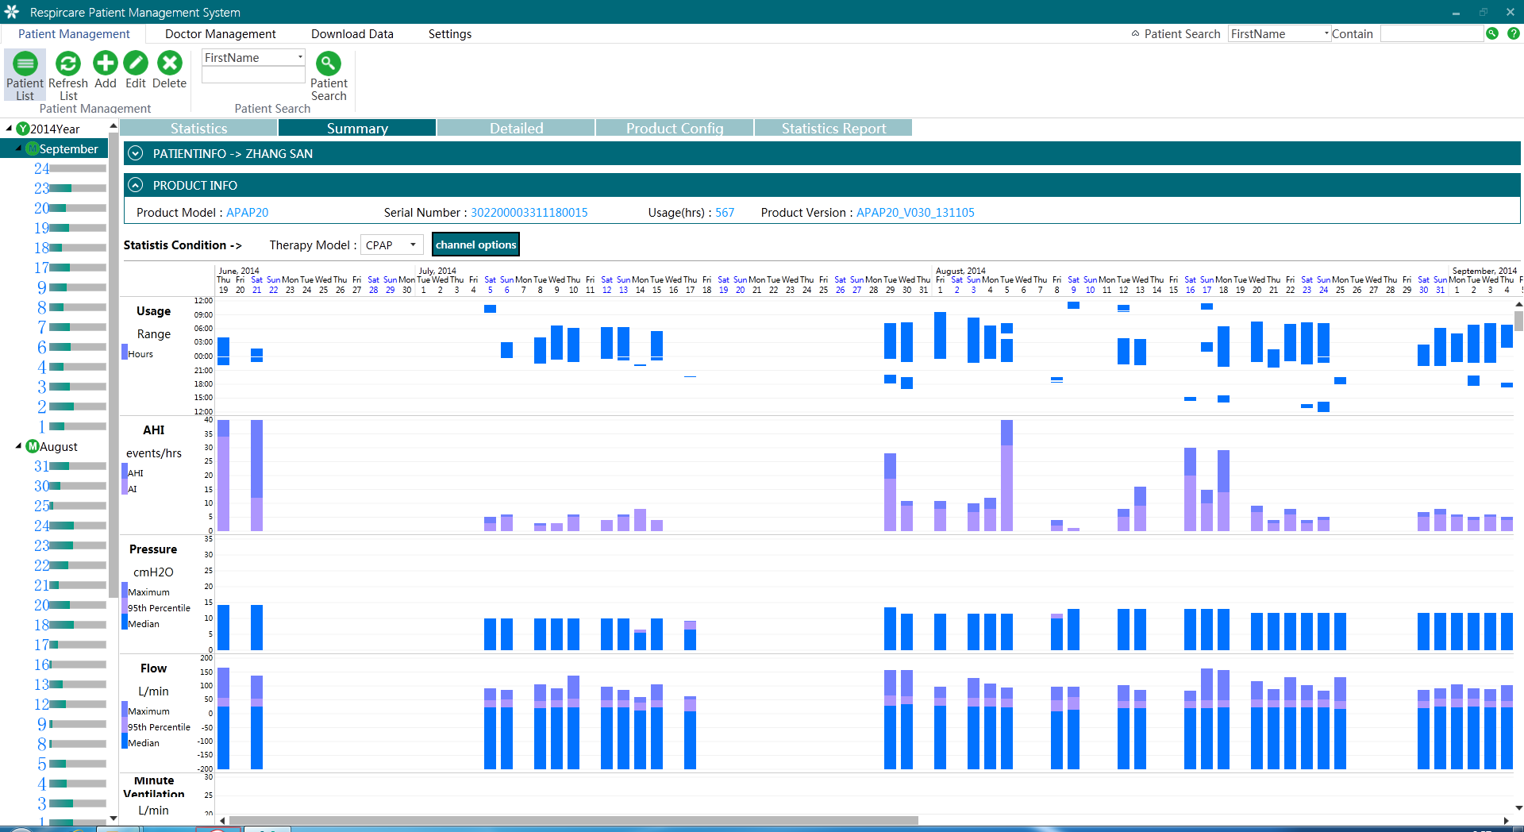

#### 3.6.2.1. Patient Information

Patient Information is the input information when adding patient, here only allows checking and no editing, if editing is required please refer to Patient Management>Edit Patient, usually it is in fold condition.



#### 3.6.2.2. Product Information

Product Information is the information patient uses the device, which including product model, serial number, total service time and product version. Serial number is the SN when adding patient. Product model, total service time, product version are reading from data card, product information could only be check and not revised.



#### 3.6.2.3. Statistics Condition

Statistics Condition could see the abstract diagram on different treatment modes, the left tree diagram and column diagram on bottom will differ with treatment modes. Press Path Option to choose to display the path entrance or not.

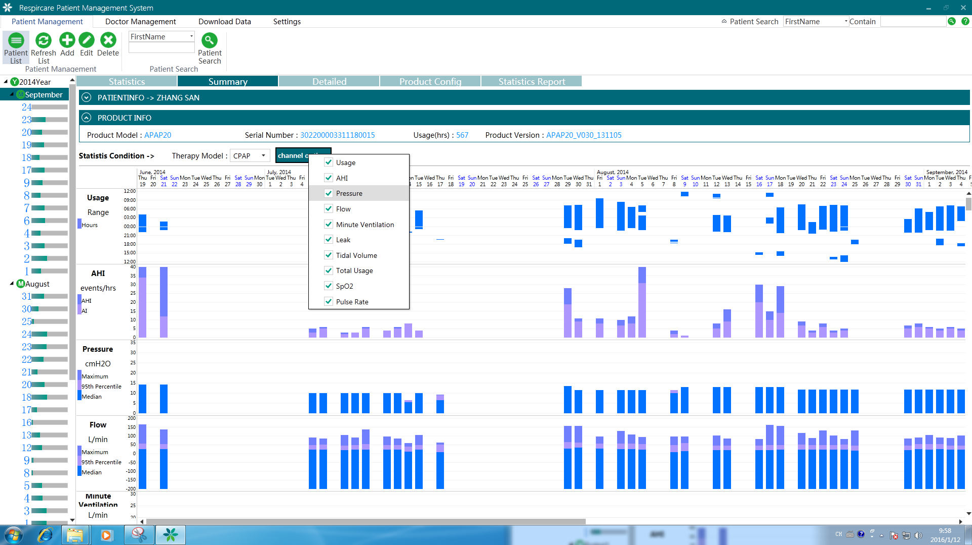

#### 3.6.2.4. Column diagram

Column Diagram is the final diagram shown as per statistics condition. It could be enlarged or reduced by moving the mouse to Y axis. When the mouse up and down, press left key on mouse to enlarge or reduce.



### 3.6.3. Details

Details interface could check the detailed diagram in one day. Horizontal is the waveform of one channel and vertical is for one day. The channel quantity differs as per device model and treatment modes.

Press Details to see the information. This interface includes patient information, product information, statistic condition, diagrams.

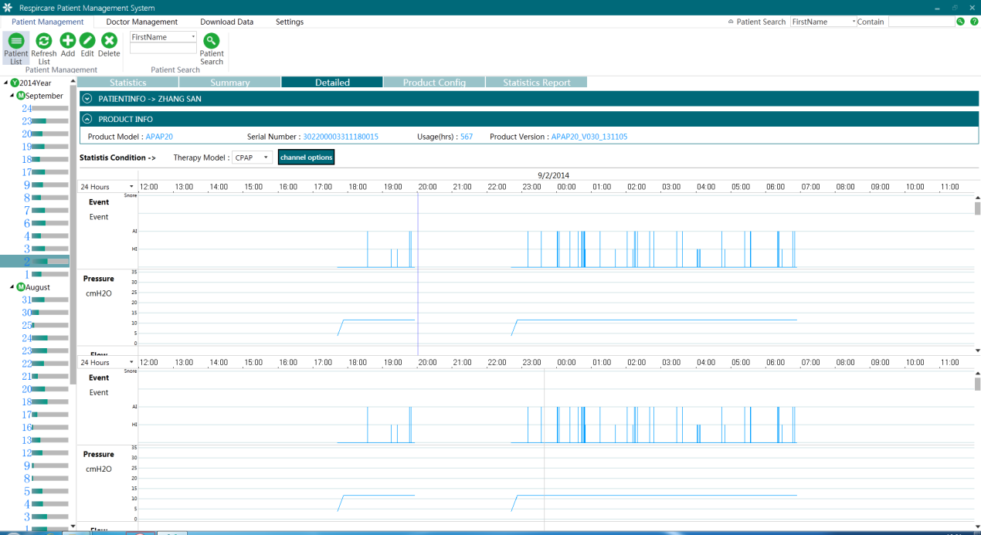

#### 3.6.3.1. Patient Information

Patient Information is the input information when adding patient, here only allows checking and no editing, if editing is required please refer to Patient Management>Edit Patient, usually it is in fold condition.



#### 3.6.3.2. Product Information

Product Information is the information patient uses the device, which including product model, serial number, total service time and product version. Serial number is the SN when adding patient. Product model, total service time, product version are reading from data card, product information could only be check and not revised.



#### 3.6.3.3. Statistic Condition

Statistics Condition could see the abstract diagram on different treatment modes, the left tree diagram and column diagram on bottom will differ with treatment modes. Press Path Option to choose to display the path entrance or not.

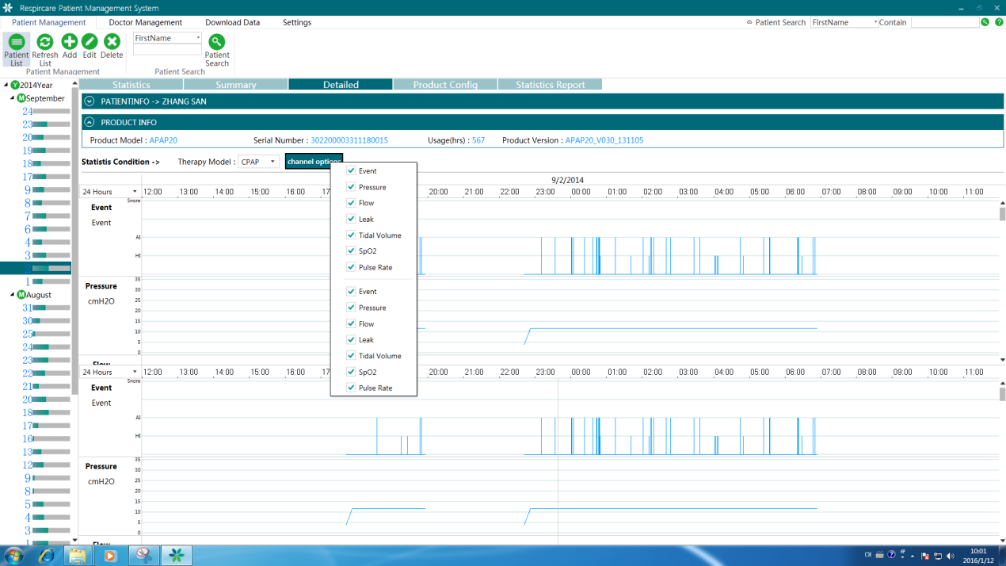

#### 3.6.3.4. Curve Chart

Curve Chart is the final displayed diagram according to statistics condition.

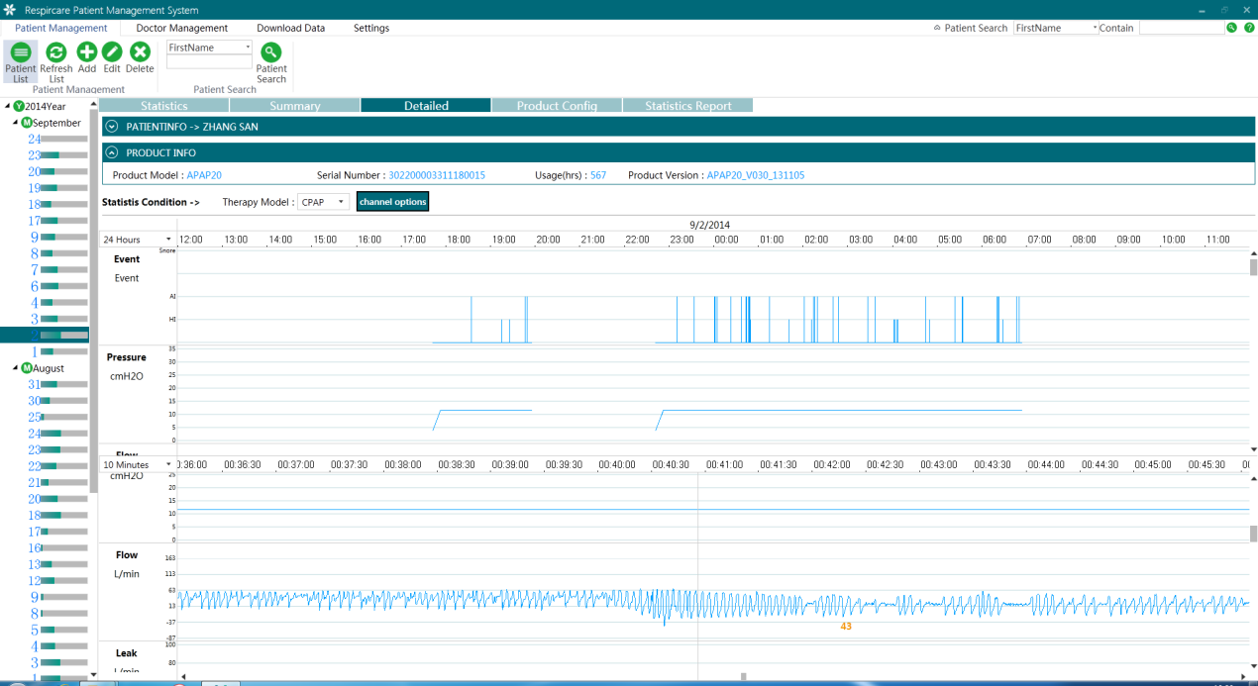

Vertical enlarge or reduce: press 24h list to choose the time period for enlargement or reducing the waves.

*Note: usually the upside is reduced curves (2h- 24h), and bottom is enlarged (10seconds- 1h)*

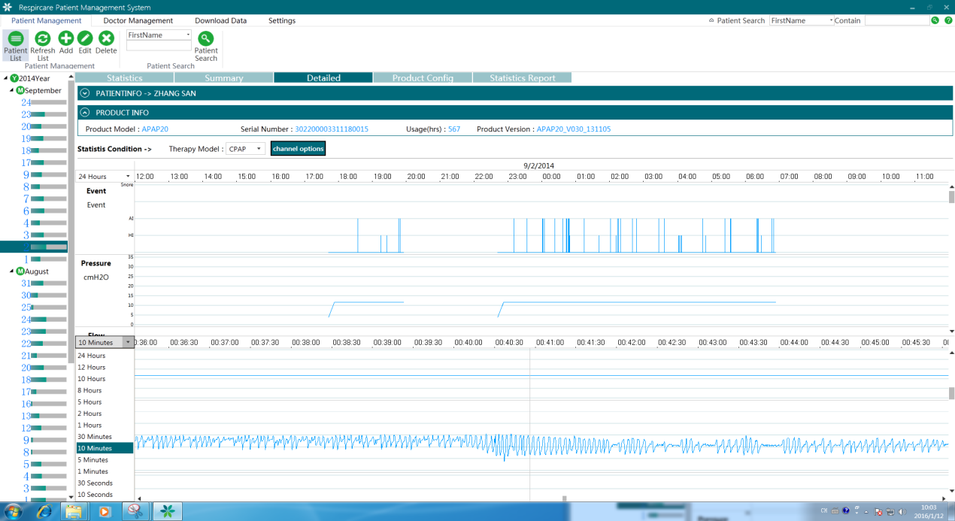

Vertical enlarge or reduce: Move the mouse to Y coordinates on the text, when the mouse into up and down arrow, hold the left mouse button and drag up and down, then the graph can be enlarged or reduced to the vertical. 

### 3.6.4. Product Configuration

Product configuration interface mainly display product configuration information, According to the statistical condition to check the product configuration of a period time under some treatment mode.

Click “Product Configuration” button into product configuration interface. Product configuration interface include “Patient information”, “Product information”, “Statistical condition” and “Product configuration” etc.

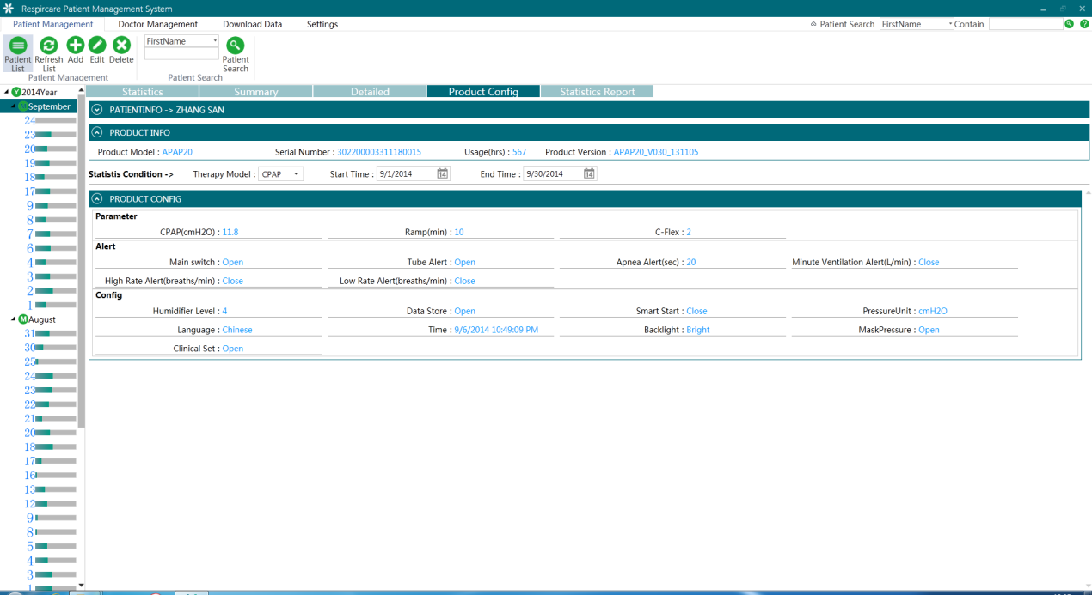

#### 3.6.4.1. Information for patients

"Patient information" is information input when the new patients, can see can't edit here, please see the "patient management" > if you want to edit the "edit patients" section, patient information is folded state by default.



* **3.6.4.2. Product information**

Patients with "product information" is information that is relevant to use the product, including product model, serial number, the total running time, product version. Fill in the product serial number, serial number is a new patient with product model, total running time, product version is automatically read the data card content, product information can only view cannot be modified.



#### 3.6.4.3. Statistics conditions

"Statistical" according to the treatment of choice mode and the starting time to check the different mode of product configuration, different treatment mode is a product configuration at the bottom of the left side of the tree and different projects.



#### 3.6.4.4. Product Configuration

Product configuration is statistical terms used within the longest product configuration information, displays the configuration parameters of different treatment mode.



### 3.6.5. Statistical Reports

Statistics report is the summary of the patient all information and statistical analysis. Can be used for a day or more days of case reporting, the report can be printed or saved as a PDF file directly.

Click on the "report" button to start the statistical report interface, statistical reporting interface including "patient information", "product information", "statistical conditions" and "report text", etc.

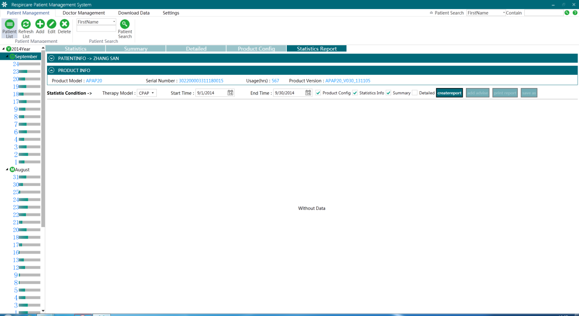

#### 3.6.5.1. Information for patients

"Patient information" is information input when the new patients, can see can't edit here, please see the "patient management" > if you want to edit the "edit patients" section, patient information is folded state by default.



* **3.6.5.2. P**[**roduct**](C:/Users/frank556600/AppData/Local/Yodao/DeskDict/frame/20160112092804/javascript:void(0);)[**information**](C:/Users/frank556600/AppData/Local/Yodao/DeskDict/frame/20160112092804/javascript:void(0);)

Patients with "product information" is information that is relevant to use the product, including product model, serial number, the total running time, product version. Fill in the product serial number, serial number is a new patient with product model, total running time, product version is automatically read the data card content, product information can only view cannot be modified.



#### 3.6.5.3. Statistics conditions

"Statistical conditions" according to the treatment of choice model and statistical reports of different starting time view mode, different treatment mode is a statistical report at the bottom of the left tree and content is different, statistics report contains project can be set up through the selection box contain or not contain, the default content does not include the detailed curve. If not choose or start time not choose statistical condition, then the "generate report" button cannot be used, if the current did not show statistical report then "add orders", "print report" and "save report" button cannot be used.



#### 3.6.5.4. Generate Reports

Click the "generate report" button to generate statistical reports, generating condition depends on the content of the statistics. Treatment patterns, different time, generate statistics report content is different. Generate a report of how much time depends on conditions and data.



#### 3.6.5.5. Add the doctor's advice

Your doctor advice is the channel of communication, medical staff and patients, medical personnel can be by adding your doctor advice to guide the patients to use products, or add some comments and special instructions.

Click on the "add orders" button, "added orders" interface, fill in the doctor's advice advice and then click the "ok" button to generate the report with your doctor advice content, the doctor's advice content must not exceed 2000 characters.

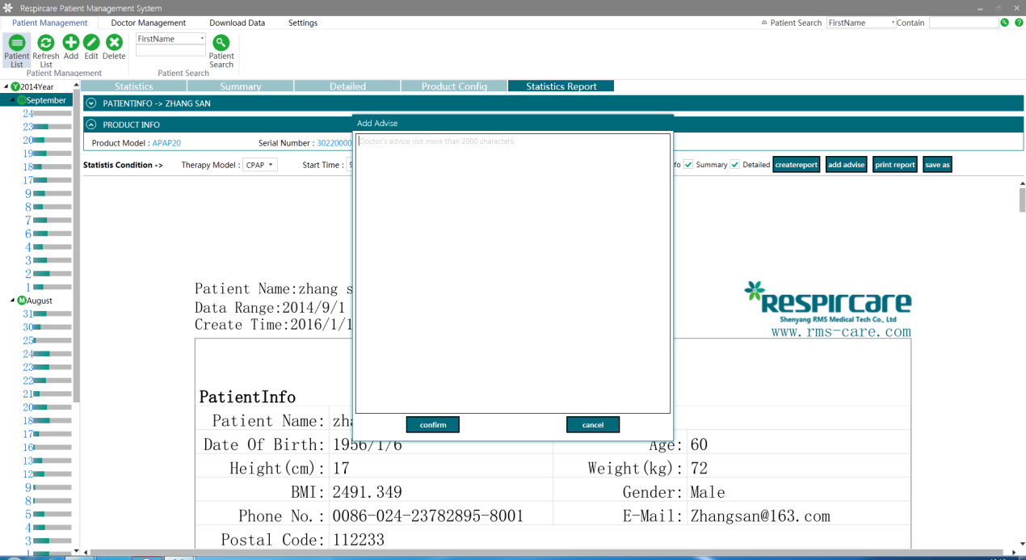

#### 3.6.5.6. Print report

For the convenience of the medical staff, patients, patients' families, from the system knowledge of product usage, the report can be printed on A4 paper.

Click on the "print report" button, to print directly to the default printer.

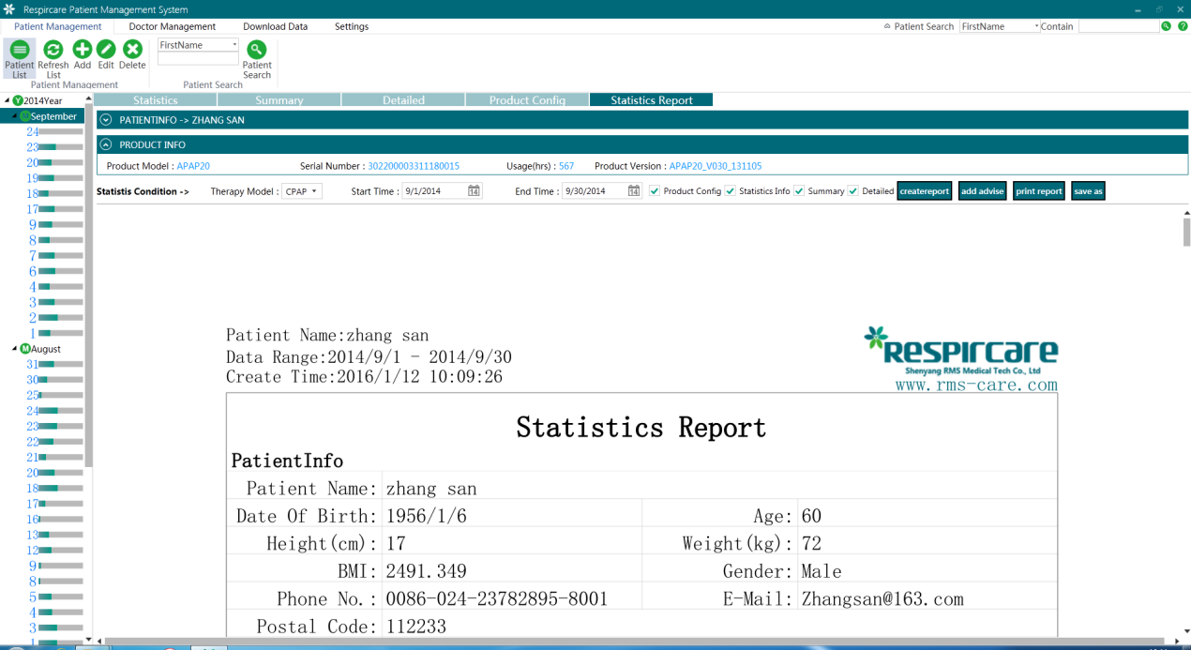

#### 3.6.5.7. Save Report

In order to facilitate the medical staff, patients, patients' families, from system to understand the situation, report can be saved as a PDF file.

Click "save report" button to pop up the save as dialog box, select a location to save and then click "save" button, the statistical report is saved as a PDF file, PDF file name + time the default name is patients.

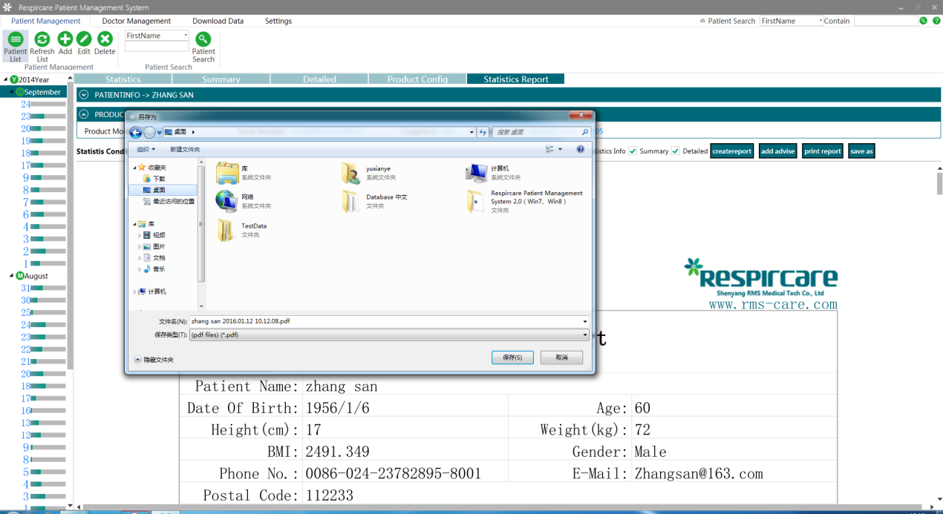

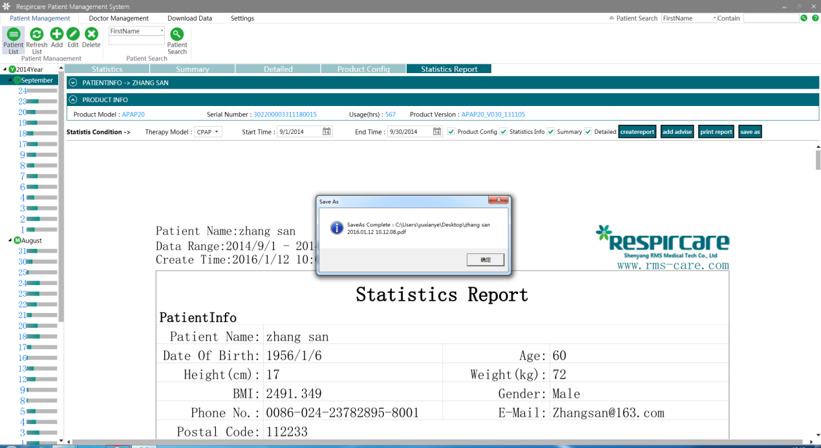

# 4. Physician management

## 4.1. Add doctor

**4.1.1.** Click on the "add" in the menu of “Doctor Management” pop up "add patient" interface.

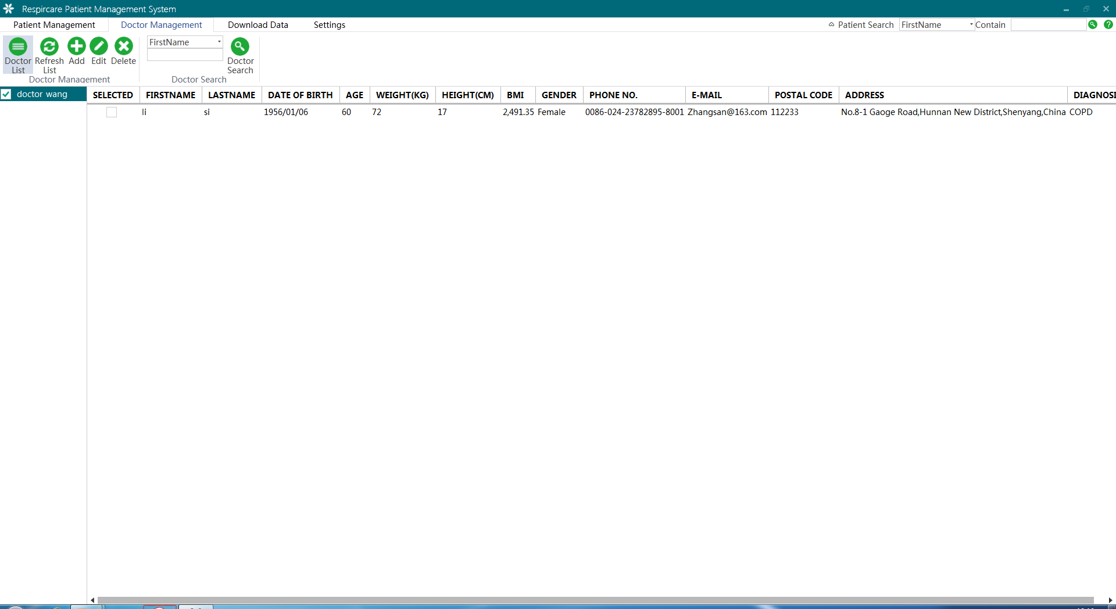

**4.1.2.** Doctor fills out the information in the "add” interface, click on "ok" button to complete adding, including name, and must fill in.

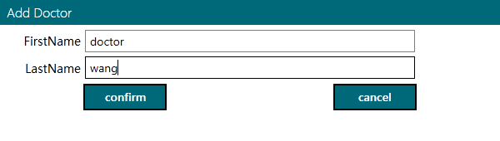

## 4.2. Edit the doctor

**4.2.1.** Selected in the list "doctor" to edit the doctor, click on the "edit" button "edit" doctor interface.



**4.2.2.** Modify the information in the "edit" doctor screen and then click the "ok" button to finish editing the doctor.

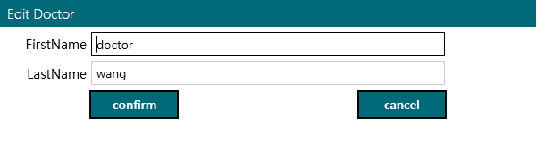

## 4.3. Delete doctor

**4.3.1.** To edit the selected in the list "doctor" of doctors, click on the "delete" button "delete doctor" interface.



**4.3.2.** Click on the "ok" in the doctor "delete" interface, delete the doctor's information.

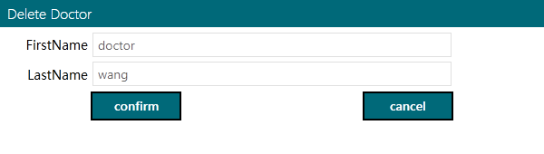

*Note: if the doctor's information and information related to patients, so can't delete the doctor's information.*

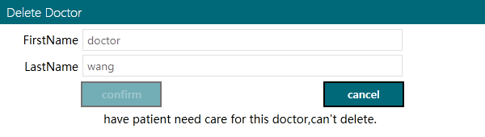

## 4.4. The doctor search

In "doctor management" menu, click "search" button, according to the search criteria and search content to find qualified doctors information quickly.

**4.4.1.** Doctors in search drop-down list, select the search criteria, fill out the contents in the search content, and then click "search" button to be related to the doctor to find the information.

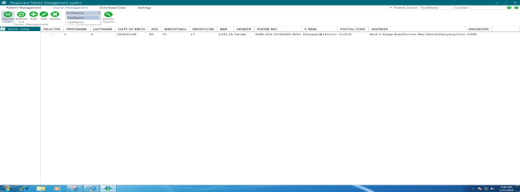 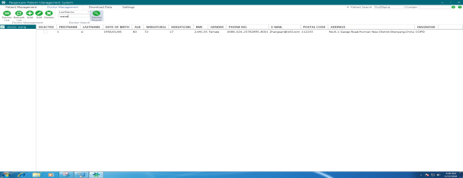

# 5. Data download

## 5.1. Open

**5.1.1.** Click“open”button, pop-up "delete" interface. open file dialog, select “SY_RMS.TXT” then click “open” button to download data, download time depends on the amount of data.

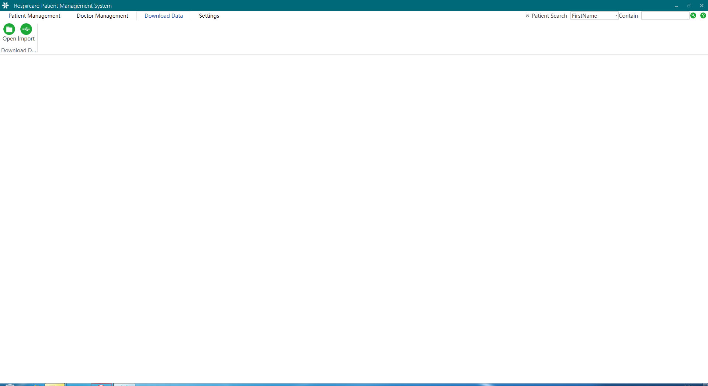

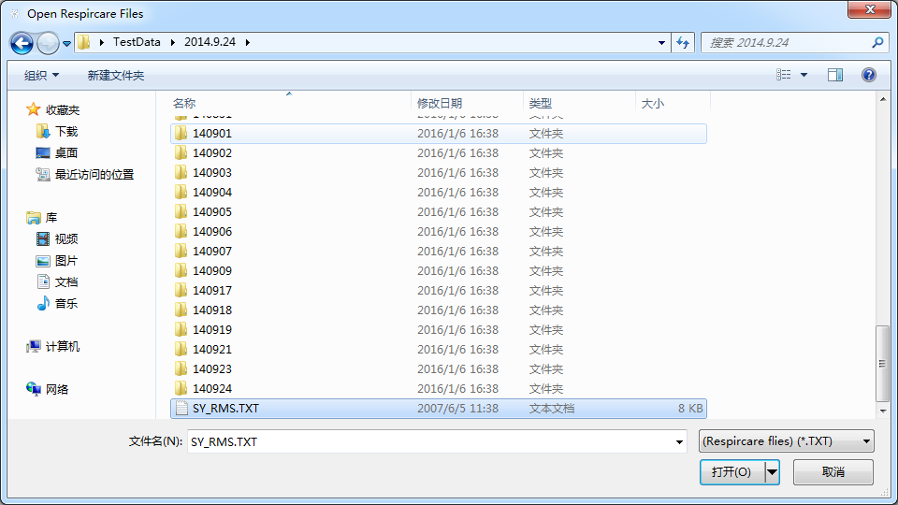

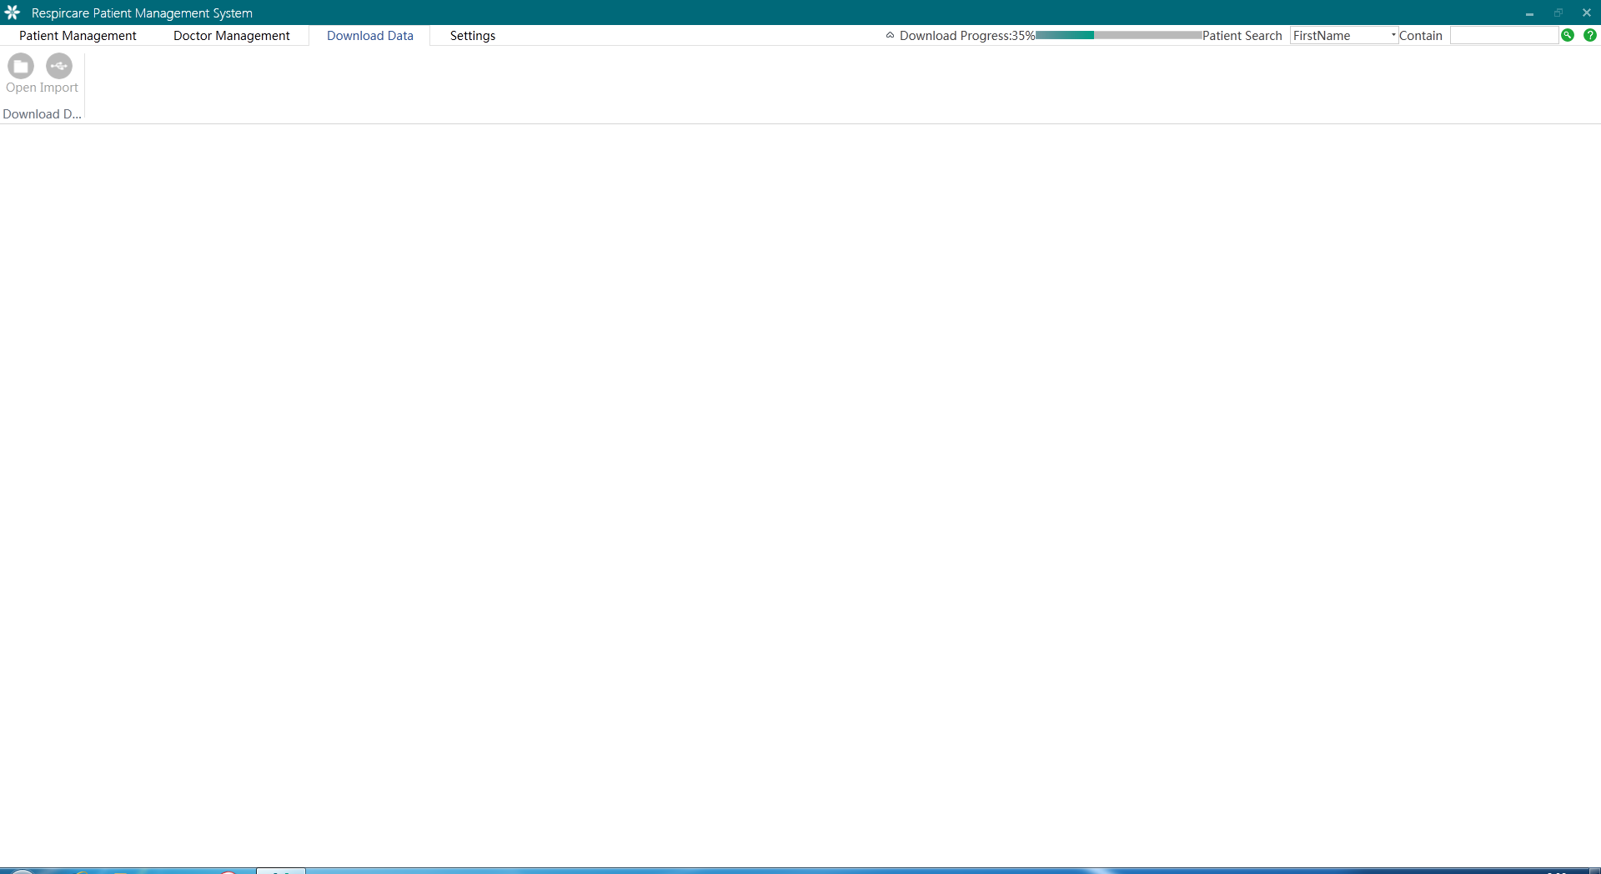

*Note: If this data of product number is not associated with patient information of product serial number, then popup "**add patient" interface, for details see the “patient management”>“add patient” chapter, the system will continue to download operation after add patient. If the data has been downloaded, then download will not be repeated.*

## 5.2. Import

**5.2.1.**Remove the SD card from the device and insert into the computer**,** when the "import" button becomes available. Click “Import” button, the system will automatically download the data in the SD card, Download time depends on the amount of data.



*Note: If this data of product number is not associated with patient information of product serial number, then popup "add patient" interface, for details see the “patient management”>“add patient” chapter, the system will continue to download operation after add patient. If the data has been downloaded, then download will not be repeated.*

# 6. Software Settings

“Software settings” include the parameters of the software settings and interface language settings.

## 6.1. Parameter

Being developed, it will increase in subsequent versions.

## 6.2. Language

Click “Language” button pop-up “Language” interface, choose the language and then click “confirm” button, interface language will show the setting language after restart the system.

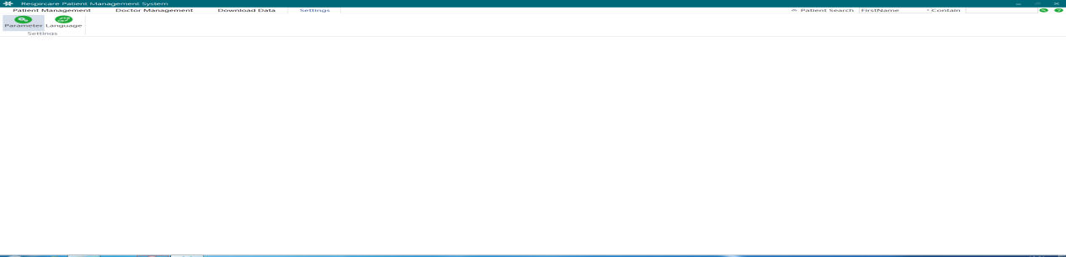

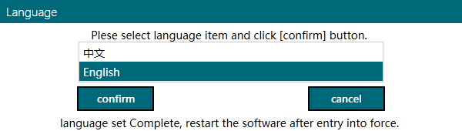

----------------------------End ----------------------------